**Deep Learning ICP-6**

**MINST_Data:**

1. **Gradient Descent Optimizer**

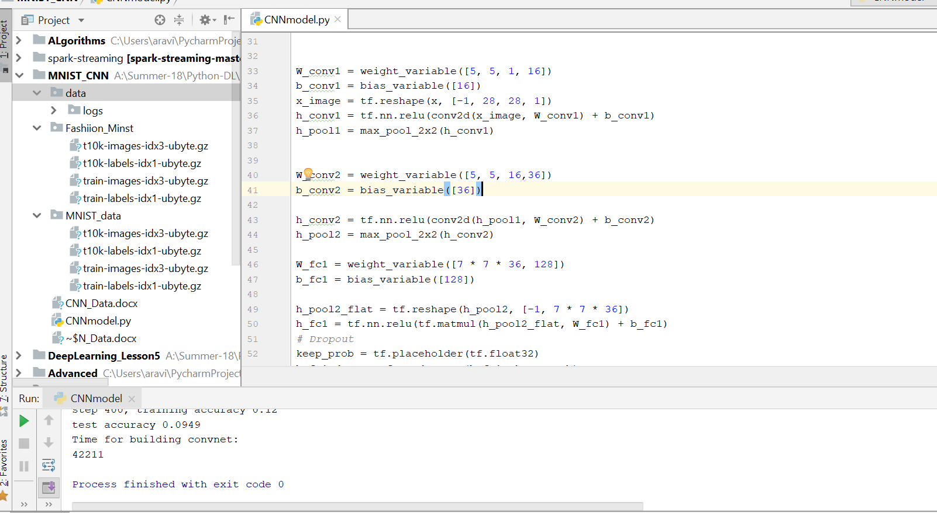

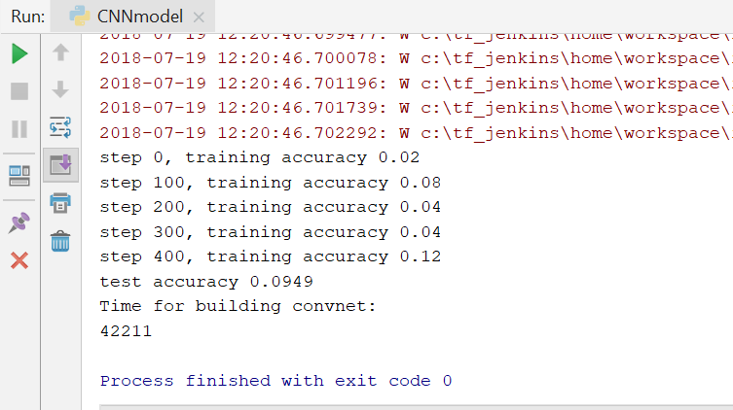

**Graph:**

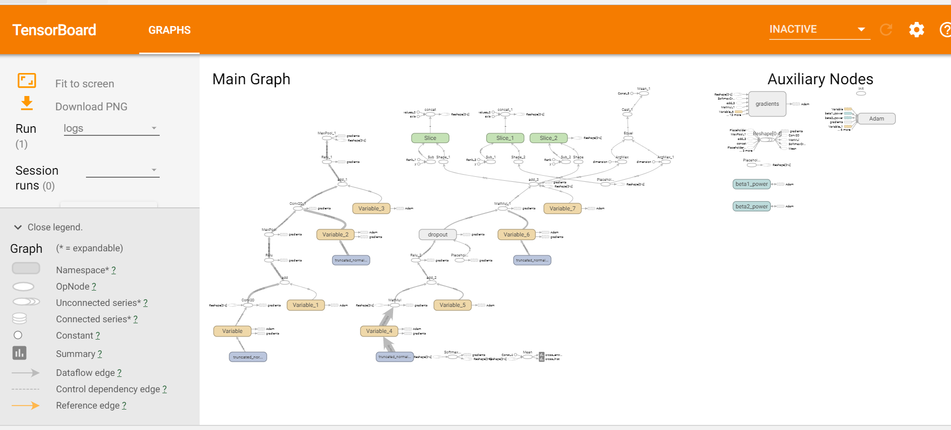

1. **Adagrad Optimizer:**

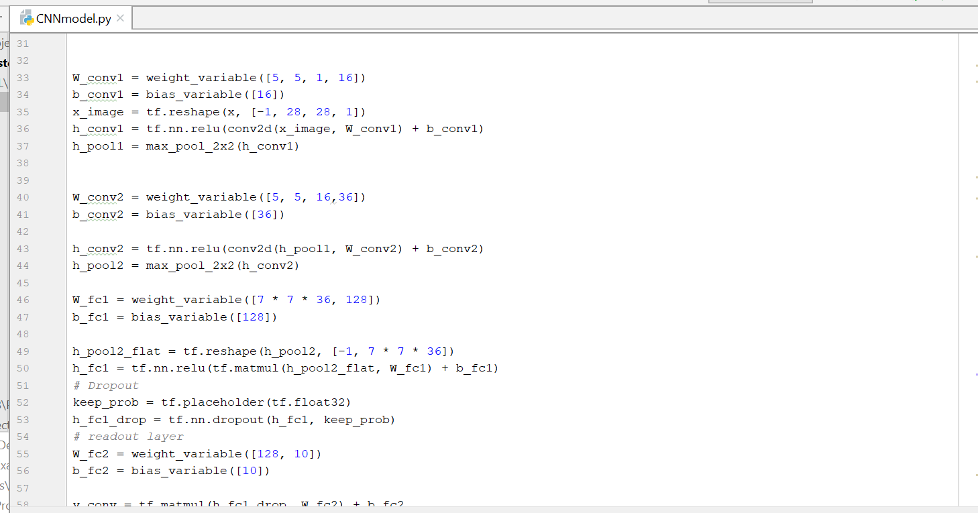

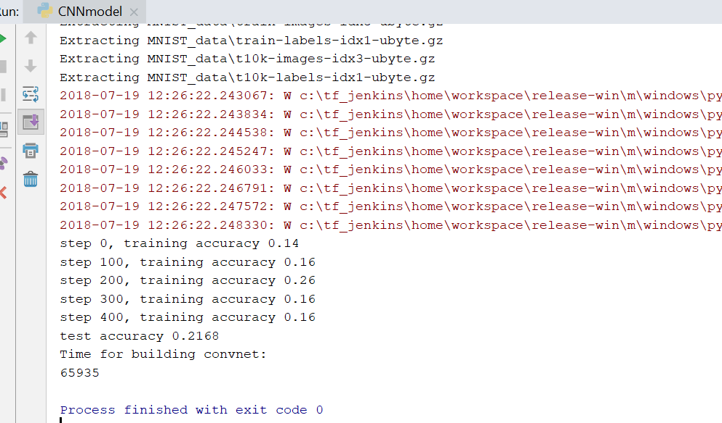

**Graph:**



**Fashion dataset:**

**1)Gradient Descent Optimizer**

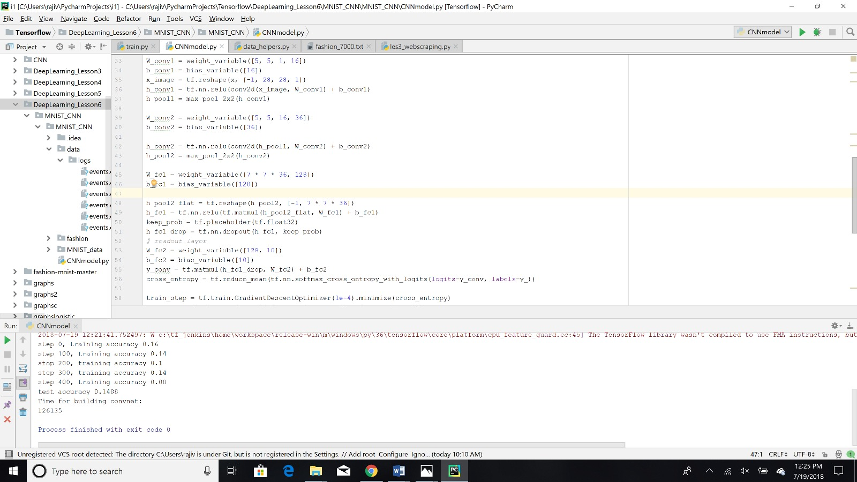

**Graph:**



**2) Adagrad Optimizer:**

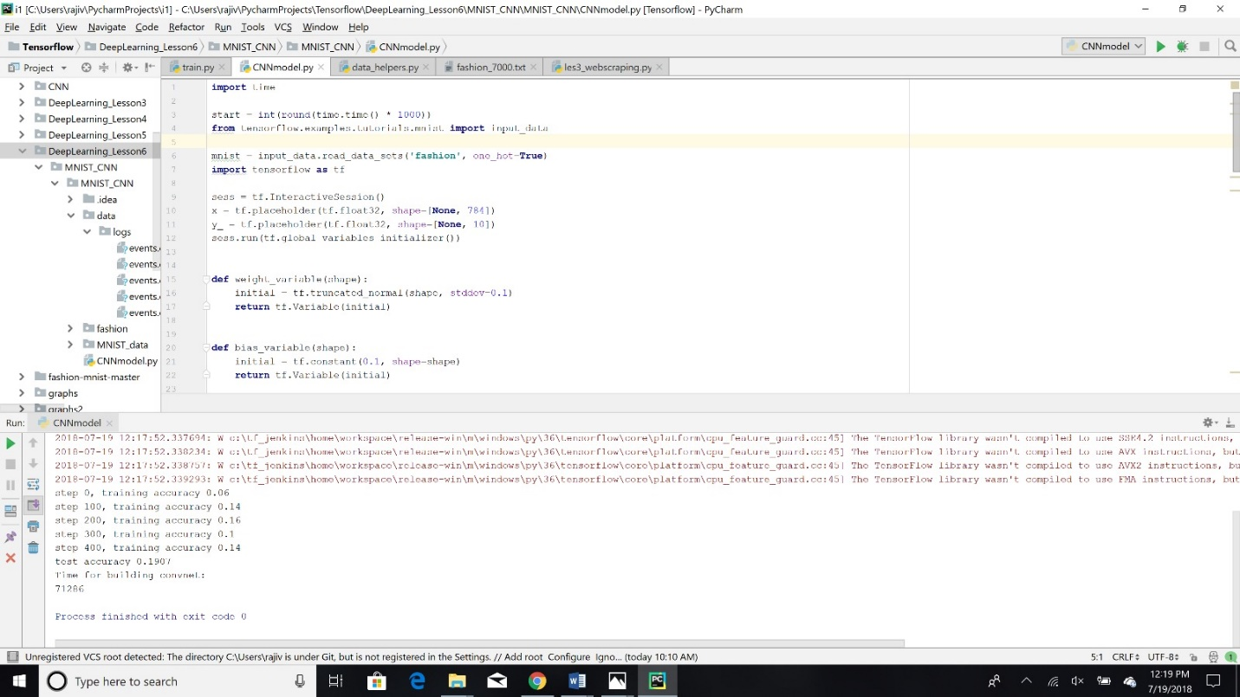

**Graph:**

